
844 Water Street
Charleston Lake Village
Athens, ON
Canada K0E 1B0
Phone: 613-924-2568
Fax: 613-924-2869
info@kelseysmarina.com
www.kelseysmarina.com

On “Beautiful Charleston, Queen of the Lakes”

CHARLESTON LAKE

MARINE SALES/SERVICE

BOATS, ENGINES, TRAILERS

ACCESSORIES & SOUVENIRS

BOAT & COTTAGE RENTALS

WATER TAXI

DOCKAGE/STORAGE

PREMIUM GAS

KELSEY’S MARINA
Charleston Lake Village
Athens, Ontario, Canada
613-924-2568
info@kelseysmarina.com
www.kelseysmarina.com

info@kelseysmarina.com

CHARLESTON LAKE

MARINE SALES/SERVICE

BOATS, ENGINES, TRAILERS

ACCESSORIES & SOUVENIRS

BOAT & COTTAGE RENTALS

WATER TAXI

DOCKAGE/STORAGE

PREMIUM GAS

Kelsey’s Marina Ltd.
May-Oct: 9am-5pm; appts available
Nov-March: e-mail or phone

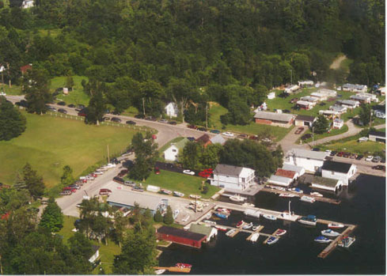

WHY EVINRUDE E-TEC, the newest 2-Stroke Technology?

14 POINTS-TO-PONDER
- No Dealer Maintenance Required for 3 yrs or 300 Hrs! Thousands less in maintenance costs.
- NEVER an oil or oil filter change - EVER!
- NEVER need to dispose of used oil - EVER!
- Winterize by yourself with the turn of the key!
- Lowest gas & oil usage on the market; learn how true planing helps save gas.
- CLEANEST engine on the market, BY FAR.
- NO MORE mixing of gas & oil; top 'er up with straight gas and let 'er rip!
- Quiet operation compared to others, esp at higher speeds!
- Turn-key start EVERY TIME,
- No smoke or vibration,
- Highest low-end torque makes this engine best for skiing, thrill rides and just plain cruising. Learn what a hole-shot really is.
- More pulling and load-power than any 4-stroke of equal HP.
- Heavy-Duty Gearcase on ALL E-Tecs makes it unnecessary for special engine models for pontoons. We don't need special "big feet" - ours already are!
- Industry-leading 5-Year Factory-Backed Non-Declining Warranty

KELSEY’S MARINA LTD, since 1967 ~ Featuring THE BEST BOAT BRANDS and EVINRUDE E-TEC OUTBOARDS

SMOKERCRAFT FAMILY of BOATS
BEST QUALITY, CONSTRUCTION and PERFORMANCE at REASONABLE PRICES
“LIFETIME PLUS SIX”
INDUSTRY-LEADING TRANSFERABLE WARRANTY

POWERED BY EVINRUDE E-TEC, OUR BOATS OUT-PERFORM ALL OTHERS, from UTILITIES to PONTOONS
*WE ACCEPT ANY CHALLENGE FROM COMPETITORS on COMPARABLE UNITS.*
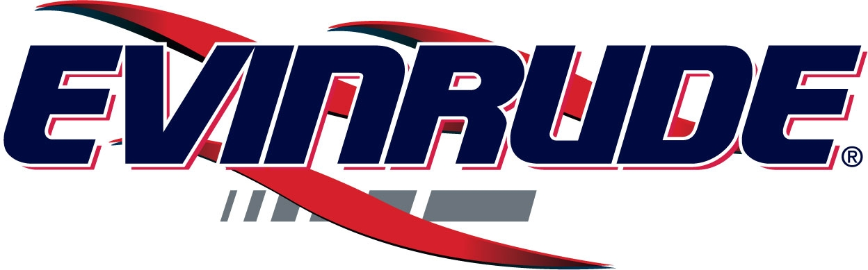

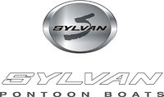

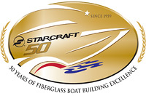


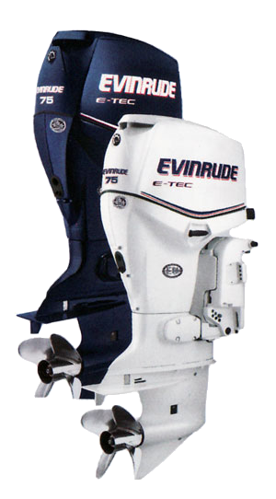
E-MAIL OR PHONE US NOW FOR BEST PRICING ON LOOSE AND PACKAGED BOATS, MOTORS and TRAILERS!
613-924-2568
info@kelseysmarina.com
www.kelseysmarina.com

